ASSESSMENT – 3

WRITTEN REPORT

SUBJECT: SYSTEM THINKING (MGT603)

NAME: MOHAMMED ZHOEB

STUDENT ID: 00287693T

LECTURER NAME: Dr Arezou PourMirza

TABLE OF CONTENTS

1. EXECUTIVE SUMMARY…………………………………………………………..
2. INTRODUCTION…………………………………………………………………….
3. IDENTIFICATION OF SYSTEM ARCHETYPES DELAYING THE…………….. PERFORMANCE
4. IDENTIFICATION OF CURRENT VALUE STREAM MAP……………………..
5. NEW VALUE STREAM MAP……………………………………………………...
6. CONSEQUENCES………………………………………………………………….
7. CONCLUSION……………………………………………………………………..
8. REFERENCES……………………………………………………………………..
9. **EXECUTIVE SUMMARY:**

* The report gives the background information about the system archetypes
* The archetypes that are responsible for the delay in the operational management of the emergency room was discussed
* Complete analysis of the current value stream map based on the system archetypes was represented
* Followed by the construction of new value stream map which reduces the time required for the waiting of the patients in the ER
* A brief explanation about the consequences that might happen related to the new value stream map is been discussed.

1. **INTRODUCTION:**

System archetype are one of the most important tools for gaining the deep knowledge of the various patterns of behavior which give the basis for the structure of system which is been studied. These archetypes might help in both ways as diagnostically and prospectively. Diagnostically these archetypes might help the manager to understand the various behavioral patterns that result to various unwanted actions which takes place within the organization. Whereas the prospective archetypes might be helpful to test the various strategies to identify the problem which help during the planning stages for easily addressing the problem (braun, 2012).

Public hospital these days are been gaining more negative feedback regarding the patients wait time because of lot of paper work and also various procedures that are been followed by the hospital staff. Patient wait time is a one of the indicator of the services that are provided by the healthcare sectors. The amount of patient waiting time is one of the factors affecting the healthcare service utilization. It has been seen in both the developed as well as the developing countries (Adamu & Oche, 2013).

1. **IDENTIFICATION OF SYSTEM ARCHETYPES DELAYING PERFFORMANCE:**

In the given scenario, the waiting time of the patients in the emergency room has been causing lot of inconvenience to the patients. As the emergency departments in most of the public hospitals have enough funding which led to the addition of more beds and staff even though the problem for the wait and delay still exist. As ER patients visit are not scheduled and they are mostly unpredictable (Christianson et al., 2019). Since this is related to the one of the system archetype that is limits to growth where there are many efforts for better performance are done but due to certain reasons the performance may be slow down even if the efforts are continued so on. Another reason for the delay is also caused because of analyzing the patients history which are been done by the doctors and nurses at the time of arrival of the patient this lead to the delay within it. This is related to the archetype called eroding goals in which the gap between the reality and goal can be reduced by taking corrective actions ("Tools for Systems Thinkers: The 12 Recurring Systems Archetypes", 2019). Here the goal is to treat the patient so as to reduce the time of waiting in the emergency room.

1. **IDENTIFICATION OF CURRENT VALUE STREAM MAP:**

As the value stream map of the emergency room provides the various systems that are involved in procedure for treatment of the patient. This can be mapped into two areas which includes the information flow and other, the material flow. The information flow usually involves patient’s medical history, treatment information, information regarding the insurance etc. whereas the material flow includes the various examination steps that are conducted by the health professionals including the nurses and doctors. Here the attending physician and nurses can be categorized through the archetype called tragedy of common, where the common resources are been used up to much by the hospital making more profits. Whereas the rooms for waiting and ER can be categorized under success to successful which defines if a group is been given more resources compared to the other group there might be higher chances of success for the group which has been given more resources (hkim, 2008).

1. **NEW VALUE STREAM MAP:**

As previously discussing about the reason for the delay in the emergency room due to long time analyzing of the patient information during addressing the patient can be solved by gathering the information of the patient much before their appointments which are schedule at a fixed time. This includes filling up the forms before the schedule appointments so that it might reduce the time at check in. Implementing the care model team who acts as an assistant in collecting the additional information like knowing more about patient medical history, going through the test results and managing the prescriptions. This can save a lot of time of the physicians who cannot get involved in the documentation process rather than assessing the patient, which in turn lead to increase in the work flow (Iafolla, 2019).

Whereas the later problem can be solved by designing the emergency rooms in different categories based on the severity of the patient. This can be done by dividing it into three different categories which includes critical care unit, intermediate care unit, and alterna care unit.

**Critical care unit**: the patients with the most acute disease or severity is been subjected to critical care unit which might include the nurse and the physician. The assessment is done by the respective diagnostic test and based on the reports the patient is been either admitted or discharged.

**Intermediate care unit:** the patients with the less severity is been assessed in the intermediate care unit. This can be done either by physician or the medical student. The respective diagnostic test are been carried out and based on the results further actions are been taken.

**Alterna care unit:** The patient with the low severity can be assessed in this unit. This can be operated with the respective timings and the availability of the physician should be based on the appearance of the case within the unit ("Value Stream Mapping the Emergency Department", 2019).

One of the additional methods that can be used to reduce the wait times is by keeping the patients vertical. For instance if the patients under non emergent category should be treated in another way rather than occupying the emergency room beds. Using the oral medications rather than intravenous injections making the less severe patients in upright position making less space occupied ("Understanding Emergency Department Wait Times | Colleaga", 2019).

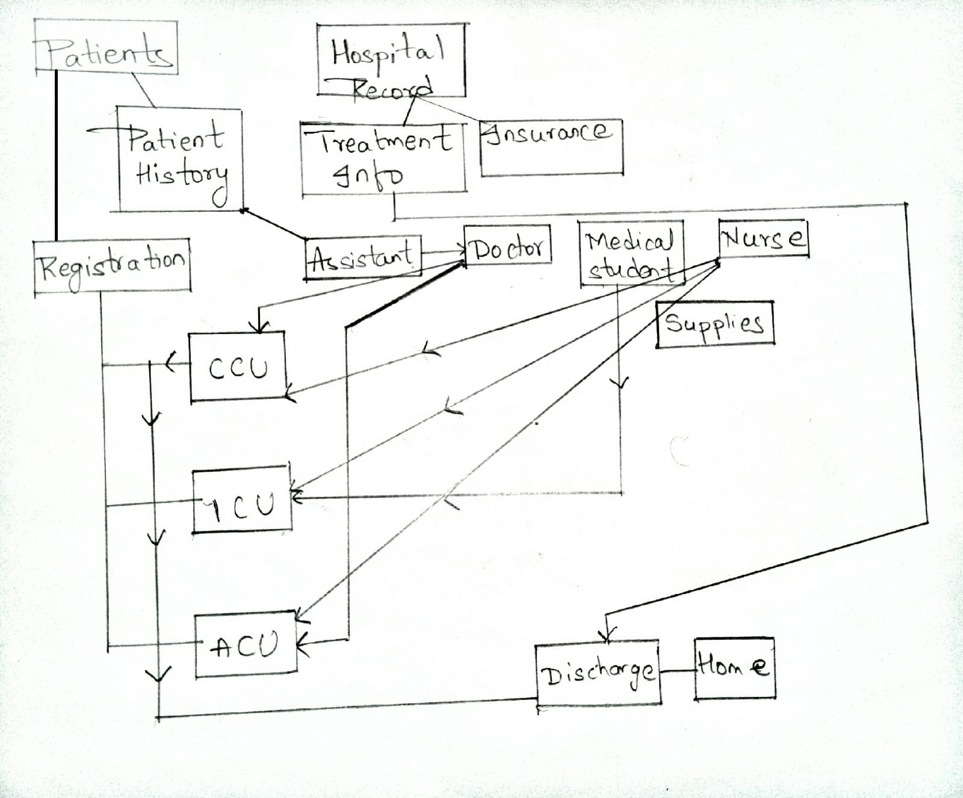

The above modified value stream map of the emergency room can reduce the time of waiting of the patients in the ER. This value stream map simplifies the ER in different categories based on the severity and the patient information can be easily processed by assigning the assistant who might be helping the doctor while addressing the patients. Whereas the treatment information and insurance can be reported to the patients at the time of discharge by the department of the hospital records. This can easily simply the process of the ER and can much effectively reduce the time.

1. **CONSEQUENCES:**

There might be overcrowding at the registration corner and might have bit chances of misplacing the patients into different care units leading to the problematic outcome.

While handling the patient information by the assistant there might be lack of understanding between the doctor and assistant if there is lack of proper medical training given to the assistant and hence they have to be trained much properly. As they are involved in handling the prescriptions and patients medical history

The critical care unit should always have enough doctors to handle the patients. This might lead to have more resources by the hospital, which in turn might lead to increase in the cost of the medical bills of the patients.

Enough of medical supplies and staff have to be assigned in each and every care units which requires more funding for the hospital.

The decrease in patient time can help in reducing the length of stay of the patient which in turn causes decrease in cost and charges and increase in payments which help to generate more revenue for the hospital which might lead the hospitals to become more money oriented.

1. **CONCLUSION:**

The above report has mentioned about the system archetypes and also its uses in both the perspectives as a diagnostically and prospectively, giving much information about the system archetypes which can be used as a tool to analyze the problems. The report has also discussed about the patients feedback about the waiting time within the emergency rooms. The value stream map of the emergency room was discussed in which the system archetypes that cause the delay within the operational management of the ER was described which include the limits to growth and eroding the goals. Further the complete analysis of the value stream map was done using the other system archetype including the tragedy of common and success to successful.

A simplified value stream map was constructed which usually simplifies the waiting time of the ER by giving the solution of how to analyze the patients information and also the addition of the assistance in the operational work flow. The other method to solve the issue includes the designing of the various care units which functions based on the severity of the patient diseases. Followed by the various consequence of the new value stream based map has been mentioned.

Using the archetypes with the various system thinking tools might help in having a broad knowledge and understanding of the organization and also their environments which in turn help in understanding the problems effectively.

1. **REFERENCES:**

braun, w. (2012). The System Archetypes.

Adamu, H., & Oche, M. (2013). Determinants of patient waiting time in the general outpatient department of a tertiary health institution in North Western Nigeria. *Annals Of Medical And Health Sciences Research*, *3*(4), 588. doi: 10.4103/2141-9248.122123

Christianson, L., Amy Laskowski, F., Peter Christensen, T., Bodell, W., Christianson, L., & McLaren, G. et al. (2019). Anatomy of a Hospital, Or Why Your ER Wait Time is So Long | Hippo Reads. Retrieved 29 August 2019, from <https://hipporeads.com/anatomy-of-a-hospital-or-why-your-er-wait-time-is-so-long/>

Tools for Systems Thinkers: The 12 Recurring Systems Archetypes. (2019). Retrieved 29 August 2019, from <https://medium.com/disruptive-design/tools-for-systems-thinkers-the-12-recurring-systems-archetypes-2e2c8ae8fc99>

hkim, d. (2008). diagnosing systemic issues and desining high leverage interventions.

Iafolla, T. (2019). 8 Ways to Reduce Patient Wait Times. Retrieved 29 August 2019, from <https://blog.evisit.com/reduce-patient-wait-times>

Value Stream Mapping the Emergency Department. (2019).

Understanding Emergency Department Wait Times | Colleaga. (2019). Retrieved 29 August 2019, from https://www.colleaga.org/article/understanding-emergency-department-wait-times